- Write a query to get unique department ID from
employee table.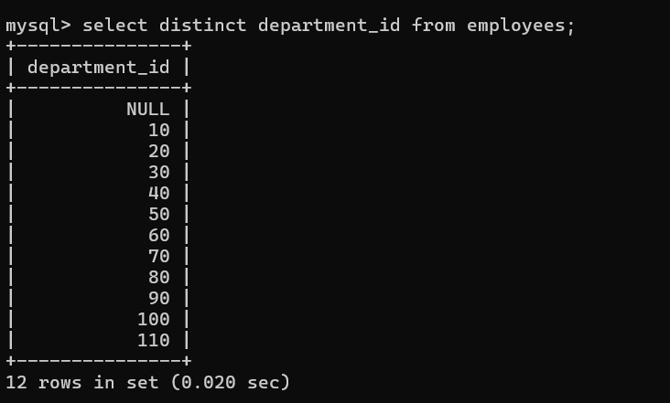
- Write a query to get all the employee’s details from the
employees table displaying the first names in descending
order.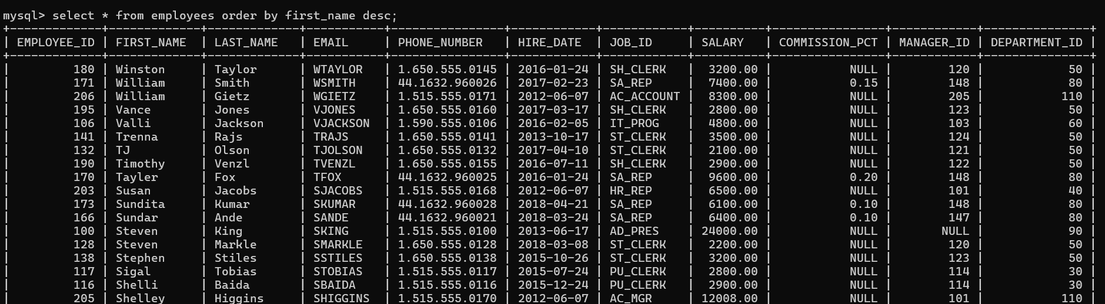

- Write a query to get the employee ID, names
(first_name and last_name), salary in ascending order of
salary.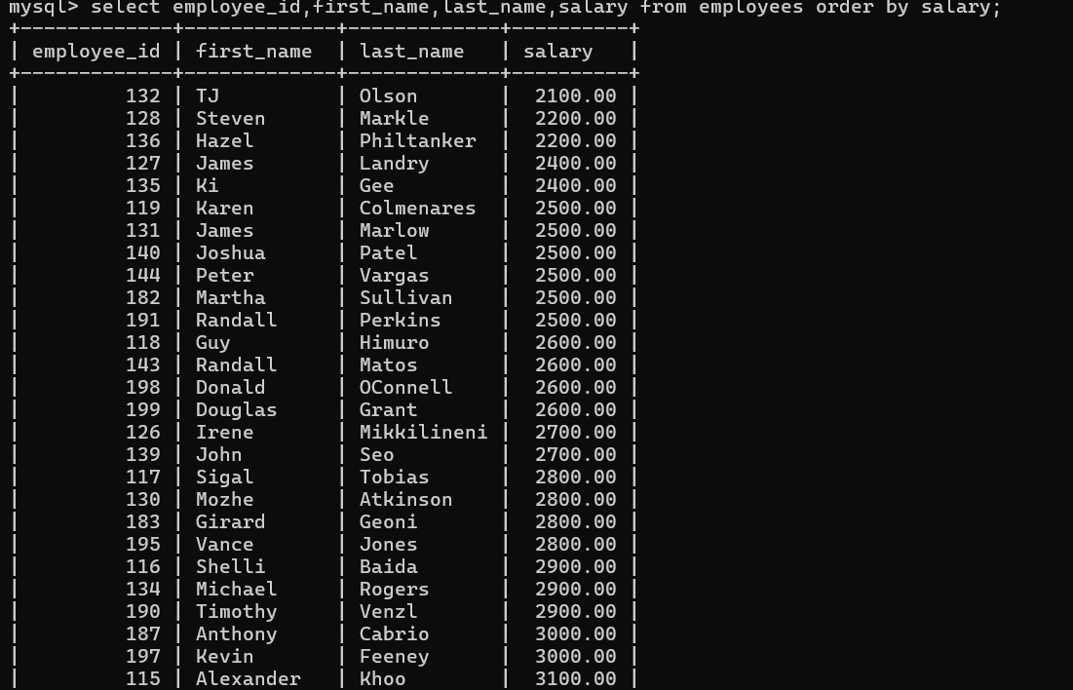

- Display first name and joining date of the employees
who are either IT Programmer or Sales Man.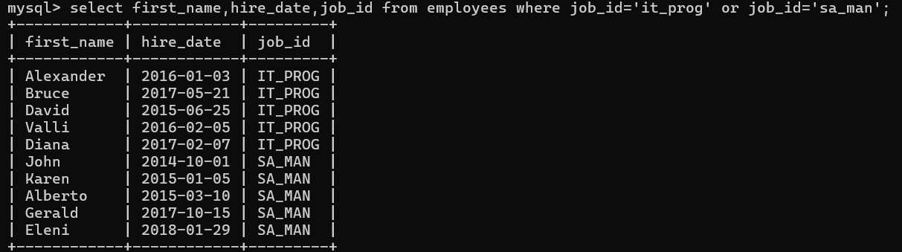

- Display details of employees with employee ID 150 or 160. 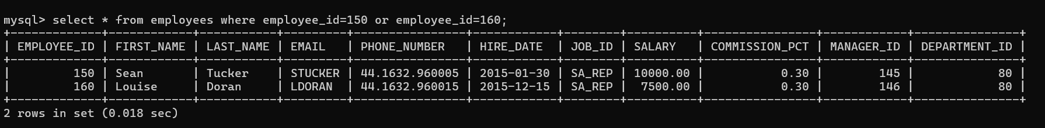

- Display first name, salary, commission pct, and hire date
for employees with salary less than 10000.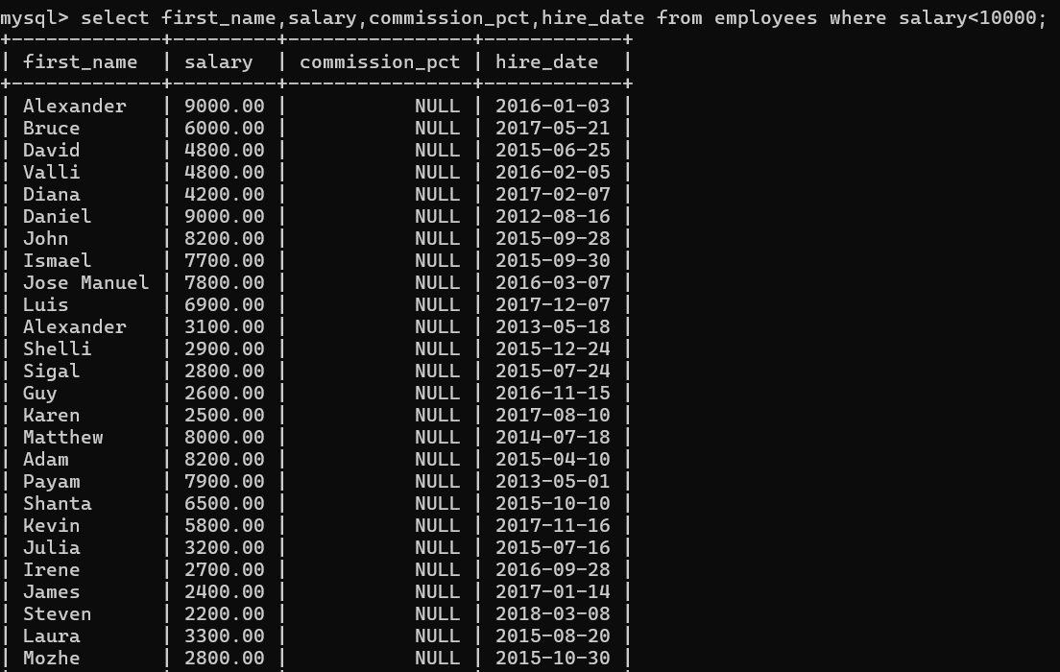

- Display employees where the first name or last name
starts with S.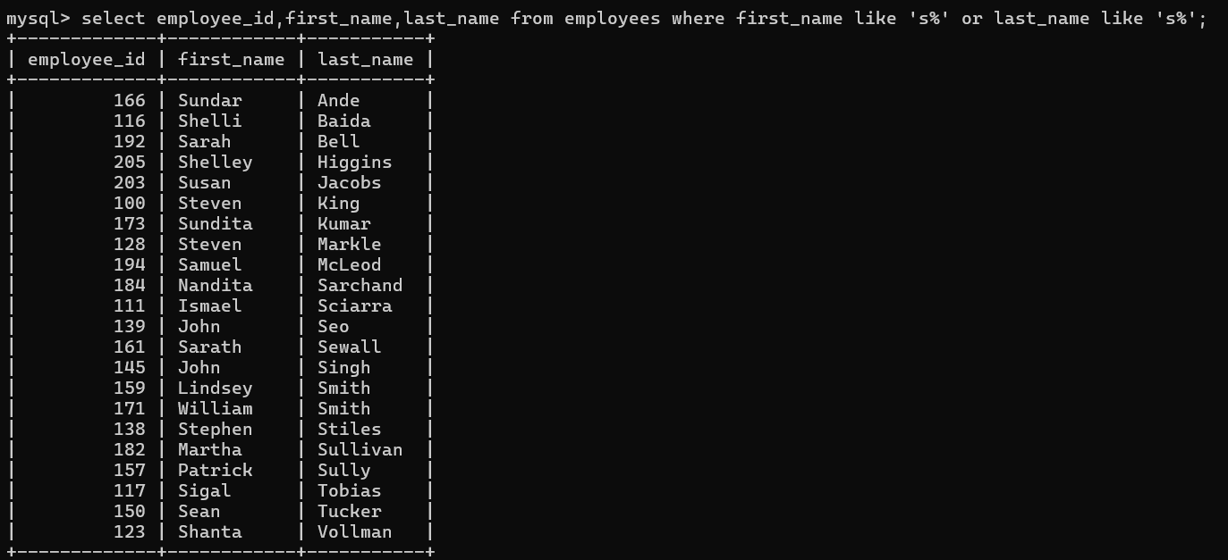

- Display details of jobs in the descending order of the title.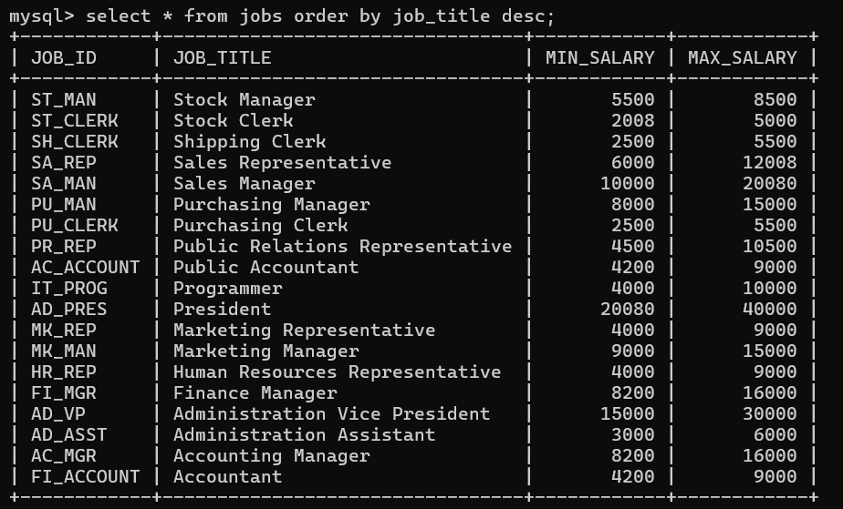

- Display the details of the employees from department 30,
earning the salary greater 10000 but do not receive the
commission.

- Display the details of employees reporting to the managers
with employee id 100 and 120.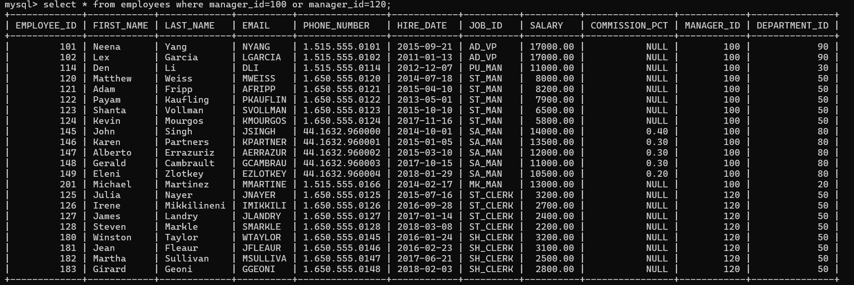

- Display the unique country_id from locations table.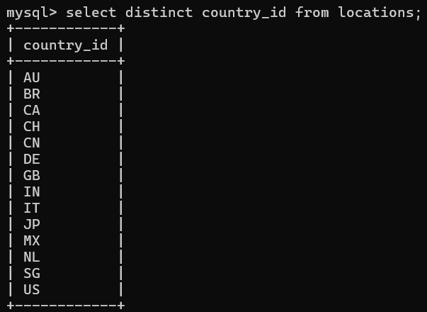

- Display all employees whose have the job_id as
IT_PROG and FI_ACCOUNT.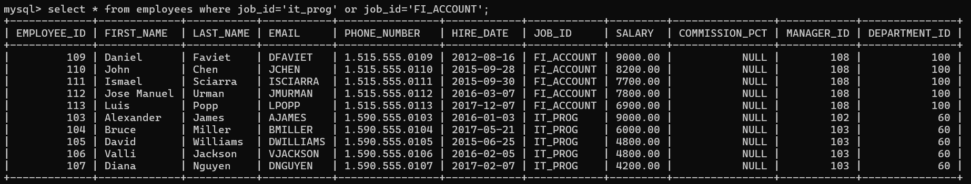

13. Display all countries in ascending order.